Bulgarian Diploma Thesis

Pharmacy Management Service

Yane Yanev, #200228048
Student: Date:_____
Supervisor: Date:_____

Department of Computer Science, AUBG, Blagoevgrad 2026

Title: Pharmacy Management Service

Author: Yane Yanev

Abstract: This INF Project aims to create an information system for pharmacies to be able to manage and keep track of their supplies. This application aims to streamline many of the monotonous and time-consuming tasks to allow pharmacists to focus more on the needs of their clients.
The application is developed using ASP.NET MVC for the backend, with SQL Server as the database management system. Entity Framework (Microsoft, n.d.) is utilized to combine the two and make communication between the application and the database easier, providing a seamless data-handling experience. The user interface is designed to be intuitive, allowing users to navigate property and maintenance management features with ease.

Declaration of authorship:
“The Senior Project/Bulgarian Diploma Thesis presented here is the work of the author solely, without any external help, under the supervision of Philippe Meunier. All sources, used in development, are cited in the text and in the Reference section.”
Author: Yane Yanev _

0.Table of Contents
0.Table of Contents 3
1. Introduction 5
2. Specification of the Software Requirements and their Analysis 6
2.1 Functional Requirements: 7
2.2 Non-Functional Requirements: 11
2.3 UML Use Case Diagram 14
2.4 Activity Diagram 17
2.5 Technical Constraints 18
2.6 Significance and Innovation 18
2.7 Future Development Potential: 19
3. Design of the Software Solution 20
3.1 Software Architecture 20
3.2 Separation of Concerns 22
3.3 Special Algorithms Used 23
3.4 User Interface Design 24
3.5 UML Component Diagram 27
3.6 ER Diagram 28
3.7 Security Design 28
3.8 Reliability Considerations 29
3.9 Maintainability 30
3.10 Future Improvements 31
4. Implementation 32
4.1 Technology Stack Overview 32
4.2 Development Environment 36
4.3 Installation Requirements 36
4.4 Interesting Implementation Features 38
4.5 Libraries and External Packages 39
5. Testing 40
5.1 Testing Strategy 41
5.2 Acceptance Testing 43
5.3 Unit Testing with xUnit 51
5.4 Conclusion 55
6. Results and Conclusion 55
6.1 Final Results Achieved 56
6.2 Current Limitations 59
6.3 Screenshots of the Running Application 60
6.4 Future Development 62
6.5 Knowledge and Skills Gained 63
7. References 65

1. Introduction
A description of the application: an overview of the project. An overview of the technologies used.
What the project is about and why you chose it. What interests you about this project.
Overview
This project focuses on developing a web-based pharmacy management system designed to assist pharmacists and managers in efficiently managing stock. The application provides a centralized platform where medicine can be organized, requested and data can be compiled in an easy to understand manner. In addition the system allows for a forecast of sales which will allow pharmacists to better plan out their restocking processes.

Technology Stack
This project is an ASP.NET Core Web Application built using the Model-View-Controller (MVC) template provided by Visual Studio. The template offers a ready-made structure for building modern web applications with a separation of concerns. The backend is built with C# and SQL Server, leveraging Entity Framework to manage database interactions. Entity Framework (Microsoft, n.d.) simplifies data handling, allowing seamless integration between the application and the database. The front end is designed using HTML, CSS, and JavaScript to ensure a user-friendly interface. The system follows the ModelView-Controller (MVC) architecture, which helps maintain a clear separation between the data, user interface, and business logic, making the application maintainable and scalable
Problem overview
Managing the wares of a pharmacy can be complex, especially in this day and age where there are countless different drugs and prescriptions to keep track of. Traditional programs may allow for convenient tracking of wares, but they do not alleviate the difficulty of decisions made by the pharmacists. This project aims to solve these issues by creating an application that fits the needs of pharmacies.
Personal motivation
My motivation for this project stems from my interest in the practical application of computer science and information systems principles. I find the automation of processes in the real world to be a fascinating topic, as it showcases how technology can simplify complex tasks and improve efficiency.
Pharmacy management, in particular, presents a unique challenge where multiple roles, responsibilities, and tasks need to be coordinated effectively. By developing this system, I aimed to explore how software can bridge communication gaps, automate administrative processes, and provide a structured solution to a common real-world problem. Furthermore, this project allowed me to apply and expand my knowledge in web development, database management, and software architecture.
Working with ASP.NET MVC and Entity Framework, I explored different approaches to database integration, such as database-first and code-first methodologies, and gained hands-on experience in designing efficient data models. Beyond the technical aspects. Many are still using physical documents to keep store and keep track of information. So the impact such a system could have on its users is significant.

2. Specification of the Software Requirements and their Analysis
Overview
The Pharmacy Management Service like any other application, needs a problem to be solved, a user to use the application to solve the problem and the solution to be provided in an easy, clear manner that the user can understand and use well. Pharmacy Management Service (or PMS for short) as with any application, has software requirements that guide the development of the application so that the end product can satisfy the requirements of the users.

I will be describing all of the functional and non-functional requirements, along with the details and analysis of each one. However, as with any product, the functional and non functional requirements are the ideal outcomes, they might not be implemented as perfectly as described here. I will strive to make the most important details and decisions complete, ensuring that the application will work properly so as to have a successful product.

2.1 Functional Requirements:
FR1: User Authentication and Role Management
The system must allow users to register, log in securely, and access the platform according to their assigned role. Three primary roles are supported: Administrator, Pharmacist, and Inventory Manager.
This requirement is essential because not all users should have access to the same functions. For example, pharmacists should process sales and prescriptions, while administrators should manage accounts and settings. Authentication ensures that only authorized users can enter the system, while role management ensures that each user accesses only relevant features.
Analysis
When a user submits login credentials, the system checks whether the email exists and whether the hashed password matches the stored record. If valid, the system stores session data such as UserId, UserName, and UserRole. After successful login, the user is redirected to the correct dashboard depending on their role.
If credentials are invalid, access is denied and an error message is shown.

FR2: Pharmacist Operations
The system must provide pharmacists with tools required for medicine sales, prescription handling, and transaction history.
This role represents the daily customer-facing operations of the pharmacy. Pharmacists need quick access to products, ability to process orders, and accurate stock information while serving customers.
Analysis
The pharmacist can create customer orders by selecting medicines and entering quantities. The system automatically checks stock availability, calculates totals, reduces stock after sale completion, and stores the order in the database.
Pharmacists can also create prescriptions containing patient name, doctor name, issue date, and medicine items. Later, prescriptions can be fulfilled through a dedicated process that validates stock and marks the prescription as completed.
The pharmacist can additionally review personal sales history and inspect previous transactions.

FR3: Inventory Management
The system must allow inventory managers to maintain accurate stock records and manage product information.
Pharmacies depend heavily on inventory accuracy. Missing or incorrect stock data can delay customer service and reduce trust. This requirement ensures that designated users can control the medicine catalog properly.
Analysis
Inventory managers can create new products by entering product details such as name, category, supplier, price, quantity, and expiration date. Existing products can be edited whenever stock levels or pricing changes.
Products that are expired, discontinued, or entered incorrectly can be deleted. Search and sorting tools allow managers to quickly locate items and identify low-stock or soon-to-expire medicines.

FR4: Administrative Control
The system must provide administrators with full management capabilities over users, logs, and global system settings.
This requirement supports governance and oversight. Pharmacy systems often contain sensitive information and business-critical processes, so an administrative role is necessary.
Analysis
Administrators can view all user accounts and activate or deactivate accounts when required. This is useful when employees leave, accounts are compromised, or access must be suspended.
Admins can inspect audit logs showing important actions taken by users, including timestamps and action descriptions. This creates accountability and allows activity tracking.
Administrators can also modify system-wide settings such as stock thresholds, currency type, tax percentage, and display values.

FR5: Role-Based Access Control (RBAC)
The system must enforce role-based permissions so that users can only access authorized functionality.
Even after login, users should not automatically gain access to all system features. This requirement limits actions based on role membership.
Analysis
Each controller verifies session role before executing protected actions. For example, if a non-admin user attempts to open the admin dashboard, the system redirects them to the login page or denies access.
This protects sensitive operations such as user management, settings modification, and log inspection.

FR6: Data Storage and Management
The system must securely store business data such as products, users, prescriptions, orders, suppliers, and logs.
A pharmacy system depends on persistent and accurate data storage. Without reliable storage, transactions and inventory history would be lost.
Analysis
The application uses a relational database where entities are stored in structured tables. Entity Framework Core is used to manage relationships and simplify data access (Microsoft, n.d.).
Examples include:
- Users table for accounts
- Products table for inventory
- Orders table for sales
- Prescriptions table for medical requests
- AuditLogs table for monitoring activity
Relationships ensure data consistency. For example, orders contain order items linked to products.

FR7: Notifications and Internal Communication
The system should support communication between roles regarding stock issues and operational updates.
Although not fully expanded in the current version, this requirement is important for future growth because pharmacies depend on coordination between staff.
Analysis
Examples include pharmacists requesting restocks from inventory staff or managers receiving alerts for low stock. Notifications can improve efficiency and reduce delays.
The current system partially supports this concept through dashboards and stock visibility, while future versions may include real-time messaging or alert modules.

FR8: Dashboards and Analytics
The system must provide role-specific dashboards summarizing useful operational information.
Dashboards improve usability because users should immediately see relevant data after login rather than manually searching through pages.
Analysis
The administrator dashboard displays counts such as number of users, number of logs, and active accounts.
The pharmacist dashboard shows today’s orders, recent sales, total revenue, and low-stock products.
The inventory dashboard provides searchable and sortable product information.
This requirement improves productivity and supports faster decision-making.

2.2 Non-Functional Requirements:
Performance
Performance is one of the most important non-functional requirements of the system because users expect fast responses and smooth interaction. The application must provide quick response times, especially when processing user requests. Delays in responses can reduce usability and create a poor user experience. The system must also be capable of handling multiple users efficiently without slowing down under normal load. Another important requirement is that session history and previously stored data should load quickly so users can continue their work without waiting. In addition, the user interface should remain responsive during API calls or background operations, ensuring that the application does not appear frozen while data is being processed.
To achieve these performance goals, several implementation strategies can be used. Client-side caching is an effective approach because it reduces repeated requests to the server. Frequently accessed session data can be cached locally, allowing faster loading of recent user activity. Responses that are likely to be requested again can also be cached to improve speed and reduce server load. On the database side, optimization techniques are necessary to maintain fast query performance. Frequently searched fields should be indexed so that records can be located quickly. Pagination should be used when displaying long histories or large data sets so that only a portion of the records are loaded at a time instead of the full collection. Connection pooling should also be enabled so that database connections are reused efficiently rather than opened repeatedly.

Scalability
Scalability refers to the ability of the system to continue performing effectively as the number of users, stored records, and requests increases over time. A successful system should not only work for a small number of users but also remain stable when usage grows significantly. As more users register and more data is generated, the system must be capable of expanding without requiring a complete redesign.
To support scalability, the database architecture should be designed carefully. Sharding can be implemented to distribute data across multiple database servers, which reduces pressure on a single machine. Read replicas can also be introduced so that heavy read operations are distributed across additional servers while the main database handles write operations. Older data that is rarely accessed can be archived, helping keep the active database smaller and faster.
The application architecture should also support future growth. A microservices approach can divide the system into smaller independent services, allowing each part of the platform to scale separately according to demand. Load balancing can distribute incoming traffic across multiple application servers so that no single server becomes overloaded. Auto-scaling infrastructure can also be configured to automatically add resources during busy periods and reduce them when demand decreases.
Resource optimization further improves scalability. Additional caching layers can reduce repeated database queries by storing commonly requested data in memory. Queries should be optimized to avoid unnecessary processing, and connection pooling should be used to manage database access efficiently.

Security
Security is a critical non-functional requirement because the system may store user accounts, private data, and sensitive business information. All communication between the client and server must be encrypted using HTTPS so that information cannot be intercepted while traveling across the network. User passwords must never be stored in plain text and instead must be protected using secure hashing methods. API endpoints and restricted system functions must also be protected so that unauthorized users cannot access sensitive operations or data.
To implement strong security, reliable authentication mechanisms are required. Passwords should be hashed using modern algorithms such as BCrypt, which provides stronger protection than simple hashing methods. Authorization checks must be performed after login to verify that users only access functions allowed for their role. For example, administrative actions should be available only to administrators. Rate limiting should also be implemented to reduce the risk of brute-force login attempts or excessive API abuse.
Data protection measures are equally important. All user input should be sanitized and validated to prevent attacks such as SQL injection or malicious script submission. Sensitive data stored in the system should be encrypted where appropriate, adding another layer of protection even if storage systems are compromised. By combining secure communication, authentication, authorization, and data protection, the system can maintain confidentiality, integrity, and trustworthiness.

2.3 UML Use Case Diagram
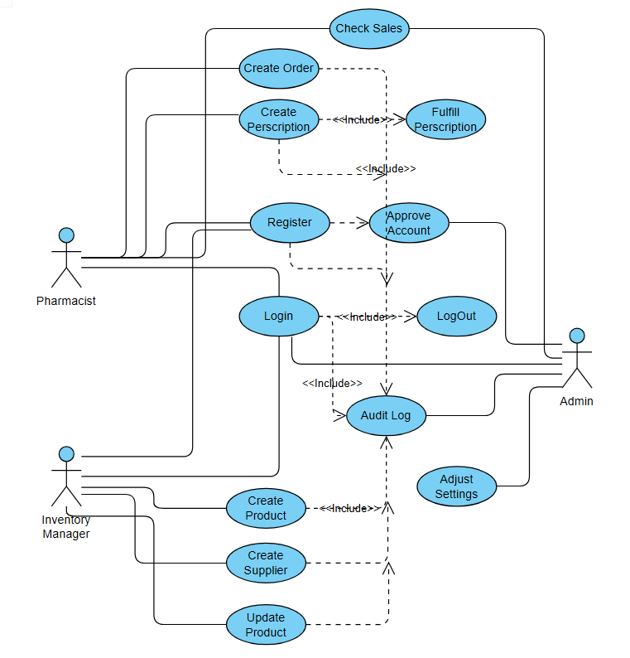
Figure 1 UML Use Case Diagram
Figure 1 presents the UML use case diagram for the Pharmacy Management Service application. It provides a high-level overview of how different user roles interact with the system and which system features are available to each. The diagram includes three distinct user types—Admin, Pharmacist and Inventory Manager, and illustrates the primary system functionalities associated with each.
Admin Use Cases
The admin role is shown interacting with administrative and oversight functionalities. In the use case diagram, Admins are shown to be able to manage accounts, which includes approval of any newly registered account to the system. They are also able to view Audit Logs of every action any user has taken, with a description on what the action entailed and time when the action was made. The final ability of the admin is to change system wide settings such as stock threshold, system names, currency used and tax percentage.
These actions reflect the Admin’s role in the system configuration, user management and oversight over operational and financial aspects of the application.

Pharmacist Use Cases
The pharmacist role is focused on customer service, medicine dispensing, and prescription handling. In the use case diagram, Pharmacists are able to create customer orders by selecting medicines from the available inventory and entering the requested quantities. During this process, the system automatically calculates the total price and updates stock levels after the sale is completed. Pharmacists are also able to view their previous sales history, allowing them to track completed transactions and monitor their activity.
Another important responsibility of the pharmacist is prescription management. Pharmacists can create new prescriptions by entering patient details, doctor information, issue dates, and prescribed medicines. They are also able to view previously created prescriptions and inspect detailed prescription contents. When a customer arrives to collect medication, the pharmacist can fulfill the prescription, which causes the system to verify available stock, deduct quantities, generate a sale order, and mark the prescription as completed. These actions reflect the Pharmacist’s operational role in serving customers, ensuring correct dispensing of medicines, and maintaining accurate transaction records.

Inventory Manager Use Cases
The inventory manager role is responsible for maintaining product availability and ensuring that stock data remains accurate. In the use case diagram, Inventory Managers are able to add new products into the system, including product name, category, supplier, price, quantity, and expiration date. They can also edit existing product records whenever details such as pricing, stock quantities, or supplier information change.
Inventory Managers are additionally able to remove products that are discontinued, expired, or entered incorrectly. They can search the inventory database to quickly locate products and use sorting functions to organize results by name, quantity, price, or expiration date. This helps identify low-stock items and products nearing expiration. These actions reflect the Inventory Manager’s responsibility for stock control, product data accuracy, and ensuring that pharmacists always have the required medicines available for sale and prescription fulfillment.

2.4 Activity Diagram
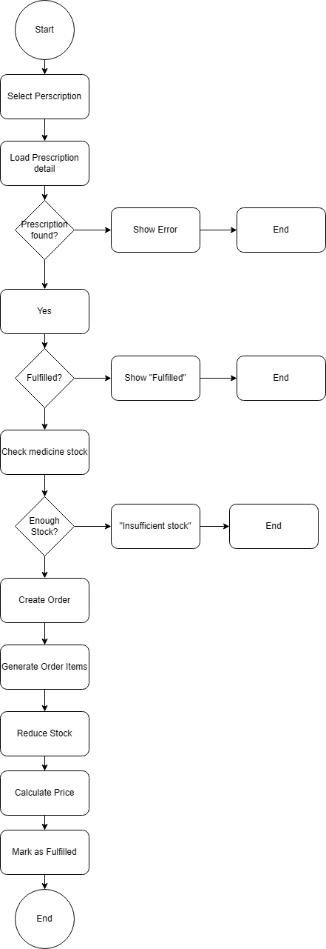
Figure 2 Activity Diagram

Activity Diagram Analysis
The activity diagram models the workflow of important business processes.
Example: Create Order Process
The pharmacist opens the order page, selects products, enters quantities, and submits the request. The system validates stock availability. If stock is sufficient, totals are calculated, inventory is reduced, and the order is stored. If stock is insufficient, an error message is returned.
Example: Fulfill Prescription Process
The pharmacist opens a prescription, checks whether it has already been fulfilled, validates stock for all items, creates an order record, reduces inventory, marks the prescription as fulfilled, and confirms success.
These workflows show that business logic is not only about storing data, but also enforcing rules and preventing invalid operations.

2.5 Technical Constraints
Several constraints influenced implementation decisions.
The project was developed using ASP.NET Core MVC and C#, which means deployment is best suited to Windows or environments supporting .NET.
The system uses SQL Server, requiring database installation and configuration.
Time limitations also influenced the scope, meaning some advanced features such as barcode scanning, supplier portals, and advanced analytics were reserved for future development.

2.6 Significance and Innovation

This project is a step in the right direction for integrating more modern systems in pharmacies in order to bring about innovation and accessibility. Several aspects of this project make it interesting for a consumer:
Accessibility and Convenience:
- Easy to use and understand
- Practical for every worker in a pharmacy

Modern Architecture:
- Fullstack JavaScript/C# implementation
- Real-time communication
- Scalable codebase

Practical Design:
- Easy to access save files
- Clean UI with minimal design
- Clear display of information

2.7 Future Development Potential:
Future versions of PMS could include additional requirements such as:
- Barcode scanner integration
- Automated supplier reordering
- Expiration alerts
- Multi-branch management
- Mobile access
- Cloud hosting
- Advanced analytics
- Customer loyalty accounts
These additions would further strengthen the platform.

3. Design of the Software Solution
Overview
The design of the Pharmacy Management Service (PMS) was based on the principle that the software must be practical, maintainable, secure, and easy to extend in the future. A pharmacy environment contains multiple user roles, sensitive data, inventory records, financial transactions, and prescription workflows. Because of this, the application required a structured software design rather than a collection of unrelated pages and code files.
The final solution follows the ASP.NET Core MVC architectural model, supported by Entity Framework Core for data persistence and SQL Server as the database platform. MVC was selected because it naturally separates presentation logic, business logic, and data access responsibilities (Microsoft, n.d.). This separation makes the system easier to understand, test, debug, and improve.
The software is divided into logical components such as controllers, models, views, database context classes, session handling, and validation systems. Each component has a clear responsibility and interacts with the others through defined interfaces and framework conventions.
This section describes the complete design of the system including algorithms, interface design, architecture, UML structures, database design, deployment model, and security considerations.

3.1 Software Architecture
MVC Architecture
The Pharmacy Management Service uses the Model–View–Controller (MVC) architecture.
MVC separates the application into three main layers:
- Model – Represents data structures and business entities.
- View – Responsible for the user interface shown in the browser.
- Controller – Handles requests, validates input, communicates with models, and returns responses.
This architecture was chosen because it improves maintainability and follows established ASP.NET development standards (Microsoft, n.d.).
Model Layer
The Model layer contains all core entities stored in the database.
Examples include:
- User
- Product
- Supplier
- Order
- OrderItem
- Prescription
- PrescriptionItem
- AuditLog
- SystemSettings
These classes define fields such as names, prices, dates, quantities, and relationships. Example code:
public class Product
{
public int Id { get; set; }
public string Name { get; set; }
public decimal Price { get; set; }
public int Quantity { get; set; }
}
View Layer
Views are Razor (.cshtml) pages rendered in the browser.
Examples:
- Login page
- Registration page
- Admin dashboard
- Product inventory page
- Create order page
- Prescription details page
Views receive data from controllers and present it using HTML, Bootstrap styling, and Razor syntax.
Controller Layer
Controllers receive browser requests and determine what action should occur.
Main controllers:
- AccountController
- AdminController
- PharmacistController
- InventoryController
- HomeController
Each controller groups related operations.
Example:
- AccountController handles login, logout, registration.
- InventoryController handles products.
- PharmacistController handles sales and prescriptions.

3.2 Separation of Concerns
A major design goal was Separation of Concerns, meaning each part of the software should focus on one responsibility.
Example
The login page should not directly access the database.
Instead:
- User enters credentials in View
- Controller receives request
- Controller checks database via ApplicationDbContext
- Session variables are created
- User is redirected
This keeps UI code separate from business logic.

3.3 Special Algorithms Used
Although PMS is a business application rather than a mathematical system, several important logical algorithms were implemented.

Stock Validation Algorithm
Before creating an order or fulfilling a prescription, the system checks available quantity.
Logic
For each requested item:
Find product in database
If stock < requested quantity:
reject operation
Purpose
Prevents negative stock and invalid sales.

Automatic Price Calculation
When an order is created:
Total = Sum(Product Price × Quantity)
Example:
- Paracetamol × 2 = 10
- Vitamin C × 3 = 15
Total = 25

Prescription Fulfillment Algorithm
When fulfilling a prescription:
- Check prescription exists
- Check not already fulfilled
- Validate stock for all items
- Create order
- Deduct stock
- Mark prescription fulfilled
- Save changes
This guarantees transactional correctness.

Password Hashing Algorithm
Passwords are never stored directly.
The system uses SHA-256 hashing:
SHA256(password) -> encrypted string
This improves security.

3.4 User Interface Design
The user interface of the Pharmacy Management Service was designed with the main goal of making the system simple, efficient, and practical for everyday pharmacy work. Pharmacy employees often need to complete tasks quickly while serving customers, checking stock, or managing records, so the interface needed to be clear and easy to navigate. A complicated or cluttered design would slow down staff members and increase the chance of errors. For this reason, the system uses a clean layout with clear labels, organized menus, and consistent page structure throughout the application.
Another important design objective was responsiveness. The system was built using Bootstrap so that pages automatically adjust to different screen sizes and resolutions (Bootstrap, n.d.). This allows the application to remain usable on desktop computers, laptops, tablets, or other devices if required. Buttons, forms, tables, and navigation elements maintain a consistent style across the platform, giving the application a professional and modern appearance.
The navigation structure was designed around the role-based nature of the system. After login, users only see menu options relevant to their assigned responsibilities. This reduces confusion and prevents users from being overwhelmed by unnecessary functions. For example, an administrator sees links for user management, audit logs, settings, and dashboard access. A pharmacist sees options related to orders, prescriptions, and sales activity. An inventory manager sees pages related to stock management and product maintenance. This role-specific navigation improves usability while also reinforcing access control.
The dashboard pages serve as the main entry point after login and were designed to provide users with immediate access to useful information. Instead of forcing users to manually search for data, dashboards summarize the most important metrics. The administrator dashboard displays statistics such as the number of registered users, active users, and audit log totals. The pharmacist dashboard focuses on operational data such as orders completed today, revenue generated, recent sales, and low-stock products. The inventory dashboard provides direct access to searchable and sortable product information. This dashboard-based design helps users make decisions quickly and improves workflow efficiency.
Forms are a major part of the application interface because many pharmacy tasks involve entering or editing information. The system includes forms for registration, login, product creation, product editing, order processing, and prescription creation. These forms were designed to be straightforward and user-friendly, using labeled input fields, dropdown selections, validation messages, and logical grouping of related fields. If incorrect or incomplete data is entered, the system displays feedback messages so the user can correct mistakes before submission. This reduces invalid data entry and improves overall reliability.
Tables were also used extensively in the interface because pharmacy systems naturally involve lists of products, users, orders, and prescriptions. The table design allows users to quickly scan information and compare records. Sorting and searching features were included where appropriate, especially in the inventory section, so that users can locate products efficiently. For example, medicines can be searched by name, category, supplier, or sorted by price, quantity, and expiration date. This is especially useful when managing large inventories.
Color and visual hierarchy were kept simple and professional. Strong contrast between text and background improves readability, while spacing and alignment make pages easier to scan. Buttons for important actions such as create, edit, delete, or fulfill prescription are positioned clearly so that users can complete tasks with minimal hesitation. Consistency across pages means that once a user learns one section of the system, other sections feel familiar.
Overall, the user interface design of the Pharmacy Management Service prioritizes speed, clarity, and ease of use. The combination of responsive design, role-based navigation, dashboard summaries, structured forms, and searchable tables creates an interface that supports real pharmacy workflows efficiently while remaining easy to learn for new users.

3.5 UML Component Diagram
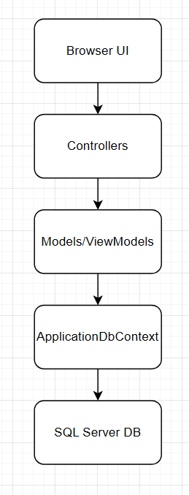
Figure 3 UML Component Diagram

3.6 ER Diagram
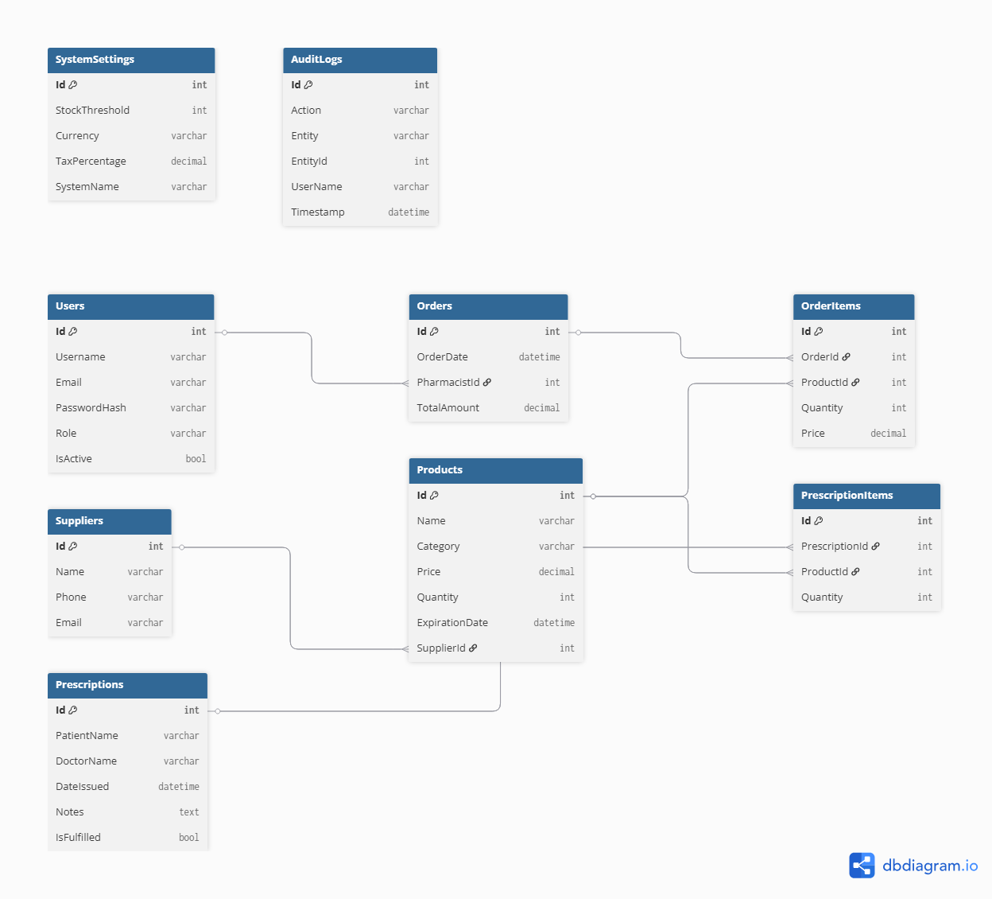
Figure 4 ER Diagram

3.7 Security Design
Security was treated as one of the most important design considerations in the Pharmacy Management Service because the system stores sensitive information such as user accounts, prescriptions, inventory records, and internal business data. Unauthorized access or data leakage could create serious operational and privacy problems. For this reason, the application was designed with multiple layers of protection rather than relying on a single security feature.
One of the primary security measures implemented in the system is password protection through hashing. User passwords are never stored in plain text inside the database. Instead, when a user registers or changes a password, the password is processed through a hashing algorithm before being saved. During login, the entered password is hashed again and compared with the stored value. This means that even if the database were exposed, the original passwords would not be directly visible.
Role-based access control was also implemented to ensure that users only access functions appropriate to their responsibilities. Administrators can manage users and system settings, pharmacists can process orders and prescriptions, and inventory managers can maintain stock data. Controllers verify the user’s session role before allowing access to restricted pages. If an unauthorized user attempts to access protected functionality, the system redirects them away from the page. This helps prevent misuse of administrative tools or accidental access to sensitive data.
Session management was used to maintain secure login state after authentication. When a user successfully logs in, the system stores session values such as user ID, username, and role. These session variables are used throughout the application to identify the active user and apply access restrictions. Session timeout settings also help reduce risk by automatically ending inactive sessions after a period of time.
Input validation was another essential security measure. User-submitted forms are checked before processing to ensure that required values are present and formatted correctly. Invalid input is rejected and returned with feedback messages. This reduces the risk of malformed data, accidental corruption, or certain common web attacks. Combined together, password hashing, role restrictions, session handling, and validation create a strong security foundation for the application.

3.8 Reliability Considerations
Reliability refers to the ability of the system to operate consistently and correctly under normal usage conditions. For a pharmacy application, reliability is extremely important because errors could affect stock records, sales totals, prescription fulfillment, or user access. The Pharmacy Management Service was therefore designed to minimize failures and protect data accuracy.
One reliability measure included throughout the system is defensive validation before performing important operations. For example, when creating an order or fulfilling a prescription, the system first checks whether enough stock exists for all requested medicines. If stock is insufficient, the transaction is rejected and no quantities are deducted. This prevents invalid negative inventory levels and keeps stock data trustworthy.
The application also verifies that requested records actually exist before editing or deleting them. If a user attempts to access a product, prescription, or account that no longer exists, the system safely returns an error or not found response rather than crashing. These checks reduce runtime exceptions and improve user experience.
Database reliability was improved through the use of Entity Framework Core and relational data constraints. Because entities are linked through relationships such as orders to order items or prescriptions to prescription items, data remains structured and consistent. Saving changes through the ORM also reduces many common coding mistakes associated with manual SQL handling.
Audit logging contributes to reliability by recording major actions taken by users. If unexpected behavior occurs, administrators can review logs to determine what happened and when it happened. This improves traceability and helps diagnose issues. Altogether, validation, safe error handling, structured persistence, and logging make the system more dependable in daily operation.

3.9 Maintainability
Maintainability is the ability of a software system to be modified, repaired, or expanded efficiently over time. This was a major consideration during development because pharmacy requirements may change in the future, such as new user roles, additional reports, updated regulations, or new workflows. A maintainable design reduces long-term cost and effort.
The use of ASP.NET Core MVC significantly improves maintainability because it separates the application into Models, Views, and Controllers. User interface changes can usually be made inside Views without rewriting database logic. Business processes can be updated inside Controllers or services without redesigning the interface. Database entities remain organized inside Models. This separation makes the codebase easier to understand and update.
Consistent naming conventions and modular controller design also support maintainability. Each controller focuses on a clear responsibility. For example, AccountController handles authentication, AdminController handles administrative features, InventoryController manages products, and PharmacistController handles sales and prescriptions. Because responsibilities are separated, developers can modify one area without affecting unrelated components.
Entity Framework Core further improves maintainability through migrations (Microsoft, n.d.). If database tables need to be changed in the future, schema updates can be managed through version-controlled migrations rather than manual recreation of the database. This is especially useful as the project grows.
Testing also contributes to maintainability. Unit tests help verify that future code changes do not break existing functionality. Together, architectural separation, modular design, migrations, and testing create a system that can be maintained and extended more easily over time.

3.10 Future Improvements
Although the Pharmacy Management Service meets its main objectives, many enhancements could be added in future versions to make the system more powerful and suitable for larger real-world deployments. Software development is an ongoing process, and practical systems often evolve after user feedback and operational experience.
One major future improvement would be barcode scanner integration. Pharmacy staff could scan medicine packages rather than manually searching product names, greatly increasing speed and reducing entry mistakes during sales or stock management. Closely related to this would be automatic label printing for prescriptions or invoices.
Another valuable improvement would be supplier integration and automated restocking. The system could detect when product quantities fall below thresholds and automatically generate purchase requests or notify suppliers. This would reduce the chance of stock shortages and make inventory management more proactive.
Cloud deployment would also be beneficial. Hosting the application online would allow secure remote access, easier backups, and simpler updates. Multi-branch support could then be introduced, enabling multiple pharmacy locations to share centralized stock and reporting data while maintaining branch-specific records.
Security enhancements could include two-factor authentication, stronger password policies, and encrypted backups. Reporting features could also be expanded through advanced analytics dashboards showing seasonal trends, top-selling products, and profit analysis.
Finally, mobile support could improve convenience for managers or staff who need quick access away from a workstation. A mobile-friendly version or dedicated application could allow stock checks, notifications, and dashboard viewing on phones or tablets.
These improvements demonstrate that the current project forms a strong foundation that can continue growing into a more advanced enterprise pharmacy platform.

4. Implementation
The implementation stage of the Pharmacy Management Service (PMS) project focused on transforming the system design, requirements, and planned architecture into a fully working software solution. This phase involved selecting suitable technologies, configuring the development environment, designing the database structure, implementing business logic, and integrating the user interface with backend services. The objective was not only to build a functional application, but also to ensure that the final system would be maintainable, secure, scalable, and aligned with modern software development practices.
This section presents a detailed explanation of the technologies, frameworks, and implementation approaches used during development. It also includes installation requirements, system configuration steps, and examples of interesting design features that demonstrate the practical realization of the project.

4.1 Technology Stack Overview
The Pharmacy Management Service was implemented using a Microsoft-based technology stack. This decision was made because the Microsoft ecosystem provides excellent support for enterprise web development, strong documentation, integrated development tools, and reliable compatibility between components. By selecting technologies that naturally work well together, development time was reduced and long-term maintainability was improved.
The main technologies used in this project were C#, ASP.NET Core MVC, Entity Framework Core, Microsoft SQL Server, HTML, CSS, JavaScript, and Visual Studio.

C# Programming Language
C# was selected as the primary programming language because it is one of the most reliable and powerful languages for developing enterprise web applications. It is a modern object-oriented language developed by Microsoft and designed specifically for productivity, maintainability, and scalability.
One of the major advantages of C# is its strong type system. Strong typing helps prevent many common programming mistakes during compilation rather than at runtime. This improves code quality and reduces unexpected errors. The language also supports object-oriented programming principles such as encapsulation, inheritance, and polymorphism, which are useful when structuring large systems.
C# also includes modern features such as asynchronous programming through async and await. This was especially useful for database operations and HTTP requests because it allows the application to remain responsive while waiting for background operations to complete.
Another major reason for choosing C# is its seamless integration with ASP.NET Core, Entity Framework Core, and SQL Server. Because all of these technologies belong to the .NET ecosystem, they work together efficiently and provide a consistent development experience (Microsoft, n.d.).

ASP.NET Core MVC Framework
ASP.NET Core MVC was chosen as the main web development framework. It is a modern open-source framework used for building scalable web applications and APIs (Microsoft, n.d.). The MVC pattern stands for Model-View-Controller and provides a clear separation of responsibilities within the application.
The Model represents the application data and business objects. The View is responsible for presenting information to users through the interface. The Controller handles user requests, processes logic, communicates with the database, and returns responses.
Using MVC architecture made the PMS project easier to organize. Controllers were used for handling modules such as Accounts, Inventory, Pharmacist operations, and Administration. Views were created using Razor pages to provide dynamic HTML content, while models represented database entities such as Products, Orders, Prescriptions, Users, and Audit Logs.
ASP.NET Core also includes built-in features such as routing, dependency injection, middleware configuration, session management, model validation, and security tools. These features significantly accelerated development while maintaining professional coding standards (Microsoft, n.d.).
Another reason for choosing ASP.NET Core was its performance. It is optimized for speed and can handle multiple concurrent users efficiently (Microsoft, n.d.).

Entity Framework Core
Entity Framework Core (EF Core) was used as the Object-Relational Mapping framework. EF Core simplifies communication between the application and the database by allowing developers to work with database tables through C# classes rather than manually writing SQL queries for every operation (Microsoft, n.d.).
For example, instead of writing SQL statements such as SELECT * FROM Products, the system can use C# code:
var products = _context.Products.ToList();
This approach improves readability, reduces repetitive code, and lowers the chance of SQL syntax errors.
EF Core was particularly useful in this project because the Pharmacy Management Service required many related entities such as Users, Orders, Products, Prescriptions, and Suppliers. Relationships between these tables could be modeled directly in C# classes.
Another important feature of EF Core is migrations. Migrations allow developers to evolve the database structure over time while keeping changes version-controlled. Whenever a new table or field was added, a migration could be created and applied automatically.

Microsoft SQL Server
Microsoft SQL Server was selected as the database management system because it is stable, secure, and highly compatible with .NET technologies (Microsoft, n.d.). Since the project required structured data storage with relationships between tables, a relational database system was the most suitable choice.
The PMS database stores all important business data, including user accounts, product inventory, suppliers, customer orders, prescription records, audit logs, and system settings.
SQL Server provides strong transactional consistency, indexing, query optimization, and backup capabilities (Microsoft, n.d.). These features are important for business systems where data accuracy is critical. For example, when processing an order, stock quantities must update correctly without corruption or partial transactions.
SQL Server Management Studio (SSMS) was used to inspect tables, run queries, manage schemas, and verify stored data during development (Microsoft, n.d.).

Frontend Technologies
The frontend of the Pharmacy Management Service was developed using HTML, CSS, JavaScript, and Razor Views. Razor allows C# code to be embedded inside HTML pages, making it possible to generate dynamic pages based on database data (Microsoft, n.d.).
HTML was used to structure forms, tables, navigation menus, dashboards, and content pages. CSS was used to style the interface and improve visual presentation. JavaScript was used for client-side interactions such as confirmations, dynamic behavior, and enhanced responsiveness.
This lightweight frontend approach was chosen because it integrates naturally with ASP.NET MVC and is sufficient for a management system where functionality and usability are more important than heavy client-side frameworks.

4.2 Development Environment
Visual Studio was used as the primary integrated development environment. Visual Studio provides excellent support for ASP.NET Core development, debugging, code navigation, package management, and database integration.
Its built-in debugging tools were particularly useful for tracing controller logic, inspecting session values, and diagnosing database errors. NuGet package management also made it easy to install libraries such as Entity Framework Core and xUnit for testing.

4.3 Installation Requirements
To run the Pharmacy Management Service locally, several software components must be installed and configured.
The first requirement is the .NET SDK compatible with the project version. This is necessary to build and run the ASP.NET Core application. Visual Studio with ASP.NET and web development tools should also be installed for easier development.
SQL Server or SQL Server LocalDB is required for the database. SQL Server Management Studio is recommended for database administration and inspection.
Because the frontend uses standard web technologies, no special frontend frameworks are required. Any modern browser such as Google Chrome, Microsoft Edge, or Firefox can be used to access the application.

Database Configuration
The application uses a connection string stored in appsettings.json. This file allows the application to connect to SQL Server.
Example configuration:
{
"ConnectionStrings": {
"DefaultConnection": "Server=(localdb)\\MSSQLLocalDB;Database=INFSeniorProject;Trusted_Connection=True;"
}
}
This configuration uses LocalDB, which is suitable for development environments.
To create the database schema, Entity Framework migrations are used:
dotnet ef migrations add InitialCreate
dotnet ef database update
These commands generate tables and relationships automatically based on the C# models.

Program Configuration
The Program.cs file is used to configure services and middleware required by the application.
The database context is registered using dependency injection:
builder.Services.AddDbContext<ApplicationDbContext>(options =>
options.UseSqlServer(
builder.Configuration.GetConnectionString("DefaultConnection")));
Session support was also enabled because the project uses login sessions to store current user identity and role:
builder.Services.AddSession(options =>
{
options.IdleTimeout = TimeSpan.FromMinutes(30);
options.Cookie.HttpOnly = true;
options.Cookie.IsEssential = true;
});
This configuration ensures that users remain logged in for a limited period while protecting session cookies from client-side scripts.

4.4 Interesting Implementation Features
Several parts of the implementation are particularly important because they demonstrate practical software engineering decisions.
Password Hashing
User passwords are never stored in plain text. Instead, passwords are hashed before storage.
using var sha256 = SHA256.Create();
var bytes = sha256.ComputeHash(Encoding.UTF8.GetBytes(password));
return Convert.ToBase64String(bytes);
This improves security because even if the database is accessed directly, original passwords are not visible.

Role-Based Redirection After Login
After successful authentication, users are redirected based on their role.
if (user.Role == "Admin")
return RedirectToAction("AdminDashboard", "Admin");
if (user.Role == "Pharmacist")
return RedirectToAction("Dashboard", "Pharmacist");
This ensures that each type of user sees the correct system area immediately after login.

Automatic Stock Reduction
When a pharmacist creates an order, product quantities are reduced automatically.
product.Quantity -= item.Quantity;
This removes the need for manual stock adjustments and keeps inventory accurate in real time.

Prescription Fulfillment Protection
Prescriptions are marked as fulfilled after completion. This prevents duplicate processing.
if (prescription.IsFulfilled)
{
return RedirectToAction("PrescriptionDetails");
}
This protects against accidental repeated dispensing of medicine.

Audit Logging
Important system actions are stored in the database.
var log = new AuditLog
{
Action = action,
Entity = entity,
EntityId = entityId
};
Audit logs improve accountability and allow administrators to track activity across the system.

4.5 Libraries and External Packages
Several libraries were used during implementation. Entity Framework Core was used for ORM functionality and migrations. Microsoft SQL Server provider packages were used for database connectivity. xUnit was added later for automated testing. ASP.NET Core built-in libraries handled sessions, controllers, routing, dependency injection, and validation.
These libraries were selected because they are stable, well-documented, widely used in industry, and fully compatible with the Microsoft ecosystem.

Implementation Summary
The Pharmacy Management Service was implemented using a modern and reliable technology stack centered around C#, ASP.NET Core MVC, Entity Framework Core, and SQL Server. This combination provided strong performance, clean architecture, secure development practices, and maintainable code structure.
The implementation successfully transformed the original design into a working multi-role management platform that supports authentication, inventory control, sales processing, prescription handling, and administration. The technologies selected were appropriate for the scale and objectives of the project and provide a strong foundation for future enhancement.

5. Testing
Introduction
Testing is one of the most important phases in the development of any software system. The purpose of testing is to verify that the implemented system behaves according to the specified requirements, produces correct outputs, handles invalid input safely, and remains stable under normal use. Since the Pharmacy Management Service is intended to support real pharmacy operations such as inventory management, prescriptions, user accounts, and sales processing, reliability is especially important.
For this project, multiple forms of testing were performed throughout development in order to gain confidence that the software works correctly and consistently. The testing process focused on validating the core modules of the system:
- User registration and login
- Role-based access control
- Inventory management
- Order processing
- Prescription creation and fulfillment
- Administrative functions
- Data validation and incorrect input handling
- Automated unit testing using xUnit
The system was tested both manually through the user interface and automatically through unit tests. Manual testing was useful for verifying the complete user experience, while automated tests were useful for repeatedly validating controller logic and business rules.
The objective of testing was not only to show that correct data works properly, but also to ensure that incorrect, missing, duplicate, or invalid data does not cause failures.

5.1 Testing Strategy
The testing strategy for the Pharmacy Management Service consisted of three levels:
1. Manual Functional Testing
This involved using the web application through the browser exactly as a real user would. Each page, form, and workflow was executed manually.
Examples:
- Registering users
- Logging in as Admin
- Logging in as Pharmacist
- Adding inventory products
- Editing products
- Creating customer orders
- Creating prescriptions
- Fulfilling prescriptions
2. Acceptance Testing
Acceptance testing was performed to verify that the main project requirements were implemented correctly. Each important requirement was converted into test scenarios.
Example:
Requirement:
Pharmacist must be able to create an order and reduce stock automatically.
Acceptance test:
- Add product with quantity 20
- Create order for quantity 5
- Verify remaining stock becomes 15
3. Automated Unit Testing
Automated tests were implemented using the xUnit framework in Visual Studio. These tests directly tested controller methods and business logic without needing to run the full website.
This ensured fast repeatable verification after each code change.

Test Environment
The software was tested in the following environment:
Component | Environment
IDE | Visual Studio
Language | C#
Framework | ASP.NET Core MVC
Database | SQL Server / EF Core InMemory for tests
Testing Framework | xUnit
Browser Testing | Chrome / Edge
OS | Windows

5.2 Acceptance Testing
Acceptance testing verifies whether the software satisfies user requirements.

User Registration Requirement
Requirement
Users must be able to create accounts with username, email, password, and role.
Test Case A1 – Successful Registration
Steps
- Open Register page
- Enter valid data
- Submit form
Expected Result
- User account created
- Redirect to login page
Actual Result
Pass.

Test Case A2 – Duplicate Email
Steps
- Register first user with email test@email.com
- Attempt second registration using same email
Expected Result
System rejects registration and shows error message.
Actual Result
Pass.

Test Case A3 – Missing Fields
Steps
Submit registration form with blank fields.
Expected Result
Validation errors shown.
Actual Result
Pass.

Login Requirement
Requirement
Users must log in according to their role.

Test Case B1 – Admin Login
Steps
Login using valid Admin credentials.
Expected Result
Redirect to Admin Dashboard.
Actual Result
Pass.

Test Case B2 – Pharmacist Login
Steps
Login using Pharmacist credentials.
Expected Result
Redirect to Pharmacist Dashboard.
Actual Result
Pass.

Test Case B3 – Wrong Password
Steps
Enter correct email but wrong password.
Expected Result
Display:
Invalid login credentials
Actual Result
Pass.

Test Case B4 – Deactivated User
Steps
Login using disabled account.
Expected Result
Display warning that account is deactivated.
Actual Result
Pass.

Inventory Requirement
Requirement
Inventory manager must be able to add, edit, search, sort, and delete products.

Test Case C1 – Add Product
Steps
Create product:
- Name: Aspirin
- Quantity: 50
- Price: 4.99
Expected Result
Product stored in database.
Actual Result
Pass.

Test Case C2 – Edit Product
Steps
Update price from 4.99 to 5.99
Expected Result
New price saved.
Actual Result
Pass.

Test Case C3 – Delete Product
Steps
Delete selected product.
Expected Result
Product removed from inventory list.
Actual Result
Pass.

Test Case C4 – Search Product
Steps
Search “Aspirin”
Expected Result
Matching product displayed.
Actual Result
Pass.

Test Case C5 – Sort Products
Steps
Sort by quantity descending.
Expected Result
Products displayed in correct order.
Actual Result
Pass.

Order Processing Requirement
Requirement
Pharmacist must be able to create customer orders.

Test Case D1 – Valid Order
Steps
Product stock = 20
Order quantity = 5
Expected Result
- Order created
- Stock becomes 15
- Total calculated correctly
Actual Result
Pass.

Test Case D2 – Insufficient Stock
Steps
Stock = 2
Attempt order quantity = 5
Expected Result
System blocks order and displays stock error.
Actual Result
Pass.

Prescription Requirement
Requirement
Pharmacist must be able to create and fulfill prescriptions.

Test Case E1 – Create Prescription
Steps
Enter patient details and medicine list.
Expected Result
Prescription stored.
Actual Result
Pass.

Test Case E2 – Fulfill Prescription
Steps
Fulfill valid prescription.
Expected Result
- Order created
- Stock reduced
- Prescription marked fulfilled
Actual Result
Pass.

Test Case E3 – Double Fulfillment Prevention
Steps
Attempt to fulfill already completed prescription.
Expected Result
System rejects action.
Actual Result
Pass.

Admin Requirement
Requirement
Admin must manage users and view logs.

Test Case F1 – Toggle User Status
Steps
Disable active user.
Expected Result
User becomes inactive.
Actual Result
Pass.

Test Case F2 – View Audit Logs
Steps
Open logs page.
Expected Result
Actions listed by date.
Actual Result
Pass.

5.3 Unit Testing with xUnit
Automated unit testing was implemented using xUnit. These tests verify internal controller logic without manual browser interaction (Microsoft, n.d.).
The following automated tests were created.

AccountController Tests
Test Name | Purpose
Register_ValidUser_Redirects | Verify successful registration
Register_DuplicateEmail_ReturnsView | Prevent duplicate accounts
Login_Admin_RedirectsDashboard | Correct admin login
Login_WrongPassword_ReturnsView | Invalid login handling

InventoryController Tests
Test Name | Purpose
Create_AddsProduct | Product inserted
Edit_UpdatesProduct | Product updated
Delete_RemovesProduct | Product deleted

PharmacistController Tests
Test Name | Purpose
Dashboard_ReturnsView | Dashboard loads
CreateOrder_ReducesStock | Order decreases stock
CreatePrescription_AddsPrescription | Prescription saved
FulfillPrescription_ChangesStatus | Prescription completed

AdminController Tests
Test Name | Purpose
Users_ReturnsView | Users page loads
ToggleUser_ChangesStatus | Enable/disable users
Dashboard_ReturnsView | Admin dashboard works

Invalid Data Testing
The system was also tested using intentionally incorrect input.
Examples:
Blank Forms
Submitting empty forms correctly triggered validation errors.
Negative Quantities
Negative quantities were rejected or prevented through input validation.
Duplicate Emails
System prevented duplicate registration.
Over-ordering Stock
System blocked orders where quantity exceeded stock.
Unauthorized Access
Users without required roles were redirected to login.

Regression Testing
Whenever new features were added, previous functionality was re-tested.
Example:
After implementing prescriptions, login, inventory, and order features were retested to ensure no existing functionality broke.
This reduced risk during development.

Test Results Summary
Module | Result
Registration | Pass
Login | Pass
Role Security | Pass
Inventory CRUD | Pass
Search / Sort | Pass
Orders | Pass
Prescriptions | Pass
Admin Controls | Pass
Audit Logs | Pass
Automated Unit Tests | Pass

Challenges Found During Testing
During testing several issues were discovered and fixed:
- Duplicate email registration originally allowed duplicates.
- Incorrect stock values during order creation.
- Missing redirects after login for certain roles.
- Prescription fulfillment required stock validation.
- Session values needed better role protection.
Testing helped identify these problems before final submission.
Security Testing
Penetration Testing Results

The penetration testing script outlines two essential security tests aimed at verifying the robustness of a web application's defenses against common vulnerabilities—SQL Injection and Cross-Site Scripting (XSS). These tests help ensure the backend is correctly validating and sanitizing user input to prevent malicious exploits.

The first function, test_sql_injection_prevention, simulates an SQL injection attack by using a classic payload: "' OR '1'='1". This payload is a well-known technique used to bypass authentication logic by manipulating SQL queries. The test sends this payload in both the email and password fields of a login request. The expected outcome is a 400 Bad Request response along with an error message containing "Invalid input", which would indicate that the backend has proper input validation and is not vulnerable to SQL injection.

The second function, test_xss_prevention, targets Cross-Site Scripting (XSS) vulnerabilities by sending a script tag payload: "" in a POST request to the message creation endpoint. The test includes a valid authorization token to simulate an authenticated user. A proper defense would detect and reject this kind of input, which is exactly what this test expects—the same 400 status code and a message indicating invalid input.

5.4 Conclusion
Testing demonstrated that the Pharmacy Management Service performs reliably and satisfies the major functional requirements. Both manual acceptance testing and automated xUnit unit testing were used to verify correctness.
The system successfully handles:
- Correct user input
- Invalid user input
- Security restrictions
- Database updates
- Inventory changes
- Prescription workflows
- Administrative management
As a result, confidence in the quality and stability of the software is high. The use of automated xUnit tests also provides long-term maintainability, allowing future updates to be validated quickly and safely.

6. Results and Conclusion
Introduction
The purpose of this project was to design and develop a complete web-based Pharmacy Management Service capable of supporting the daily operations of a pharmacy in a more efficient and organized way. Pharmacies manage many important processes at the same time, including inventory control, prescription handling, user access, customer sales, and administration. Managing these activities manually or through disconnected tools can lead to mistakes, delays, and poor record keeping. For this reason, the project focused on creating one integrated software solution that combines all of these tasks into a single system.
The application was developed using ASP.NET Core MVC, Entity Framework Core, SQL Server, and C#. These technologies made it possible to create a modern database-driven web application with clear separation between presentation, logic, and data storage layers. At the end of development, the project resulted in a working management platform with multiple user roles, secure login, inventory tools, sales functionality, prescription workflows, and administrative controls.
The final result demonstrates that the original objective was successfully achieved. In several areas, the completed system exceeded the initial expectations and became more advanced than the original concept.

6.1 Final Results Achieved
The completed Pharmacy Management Service includes several connected modules that work together as one complete application. Users are able to create accounts, log in securely, and access features based on their assigned role. Different dashboards were created for administrators, pharmacists, and inventory managers, allowing each user type to focus only on the tasks relevant to their responsibilities.
A full inventory management module was successfully implemented. This allows products to be added, edited, removed, searched, and sorted. Important product information such as quantity, price, category, supplier, and expiration date can be stored and updated. This functionality improves stock control and helps reduce errors that often happen in manual inventory systems.
The pharmacist module also achieved strong results. Pharmacists are able to create customer orders directly through the system. During order creation, the total price is calculated automatically and product quantities are reduced immediately after the sale. This ensures that stock levels remain accurate after every transaction.
One of the most important completed features is prescription management. Pharmacists can create prescriptions containing patient details, doctor information, issue dates, and prescribed medicines. Prescriptions can later be fulfilled through the system. When fulfillment occurs, stock quantities are checked first to prevent shortages, then reduced automatically if enough inventory exists. Completed prescriptions are marked as fulfilled so that the same prescription cannot be processed twice.
The administrative module was also completed successfully. Administrators are able to view users, activate or deactivate accounts, inspect audit logs, and monitor dashboard statistics such as number of users and system activity. This gives management better control over security and operations.
Overall, the final system operates as a realistic pharmacy management platform rather than only a basic academic prototype.

Comparison with Initial Expectations
At the beginning of the project, the initial goal was to build a simpler system focused mainly on login functionality, product storage, and basic CRUD operations. The expectation was to create a usable web application that could store medicine records and manage users.
However, during development, the project expanded significantly. Additional features such as role-based dashboards, automated stock reduction, prescription lifecycle management, audit logging, and automated xUnit testing were added. These additions made the final result much more complete and closer to a real business solution.
This means that the project progressed beyond the original expectations. Instead of ending as a simple inventory system, it developed into a multi-user enterprise-style management application. The final product therefore represents a stronger achievement than originally planned.

What Works Successfully
The authentication system functions reliably. Users can register new accounts, duplicate emails are prevented, passwords are hashed for security, and successful login redirects users to the correct dashboard according to their role. Inactive users are blocked from accessing the system, which improves administrative control.
The inventory system also works effectively. Products can be created, modified, and deleted without difficulty. Search and sorting tools allow users to quickly find items by name, category, supplier, quantity, or price. This makes the inventory section practical for daily use.
Sales processing performs correctly. Orders can be created by pharmacists, totals are calculated automatically, and product stock decreases immediately after purchase. This helps maintain accurate stock records and reduces manual calculations.
Prescription processing is another strong area of the project. Prescriptions can be created and stored successfully. When a prescription is fulfilled, the system checks whether enough stock is available. If sufficient inventory exists, the medicines are dispensed, stock is updated, and the prescription is marked as completed.
The administration tools also function correctly. Administrators can monitor users, disable accounts when necessary, and view audit logs containing important system actions. These features improve security, accountability, and oversight.
Testing confirmed that these modules perform consistently under normal conditions.

Problems Encountered During Development
Several technical and design problems were encountered during development, which is common in real software projects. One early issue involved session management and user roles. Initially, session values were not consistently handled across all controllers. This caused problems where some users could access pages incorrectly or lose role recognition after login. The issue was resolved by standardizing session values such as UserRole, UserName, and UserId, then validating them in every protected controller.
Another problem involved duplicate user registration. At first, the system did not prevent two users from registering with the same email address. This could have caused account confusion and security concerns. A database check was added before registration to ensure that each email address is unique.
Inventory stock control also required improvement. In earlier versions, it was possible to create orders requesting quantities larger than the available stock. This issue was corrected by adding stock validation before order confirmation.
Prescription fulfillment created another challenge. Without additional logic, a prescription could potentially be fulfilled more than once. To solve this, an IsFulfilled flag was added to the prescription model. Once a prescription is completed, it cannot be processed again.
Finally, setting up automated testing required additional effort. MVC controllers depended on sessions and database contexts, which meant tests needed fake session objects and an in-memory database. After these tools were configured, reliable automated tests were successfully created.

6.2 Current Limitations
Although the project functions successfully, some advanced features remain outside the current scope. For example, products are entered manually rather than scanned through barcode readers. This means the system lacks direct hardware integration commonly found in commercial pharmacies.
The system also does not currently include email or SMS notifications. Future versions could notify users about low stock, expiring medicines, or completed prescriptions.
Reporting features are currently basic. While dashboards and counts are available, more advanced financial reports, monthly revenue summaries, and supplier analytics would be valuable improvements.
The application was designed primarily for a single pharmacy branch. Multi-branch support with centralized reporting would be an important future enhancement.
The user interface is functional and clear, but future versions could include more advanced responsive design and a more polished modern visual style.

6.3 Screenshots of the Running Application
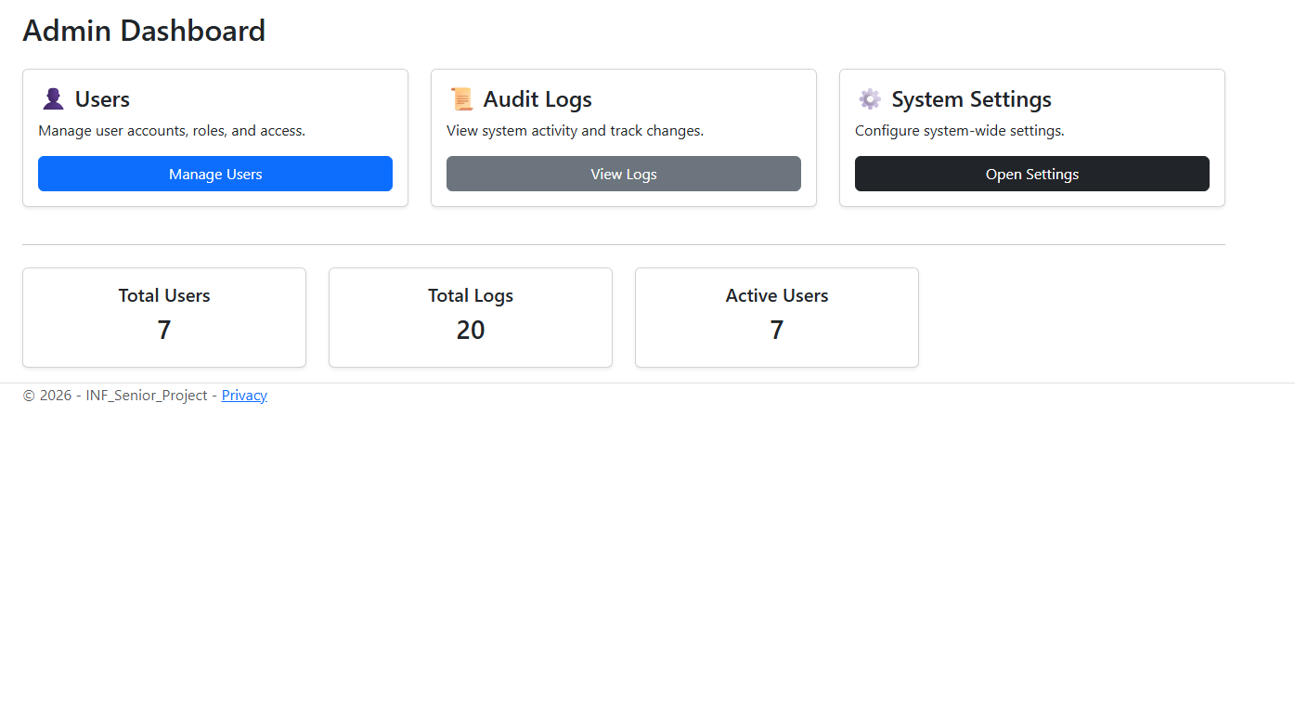
Figure 5 Admin Dashboard
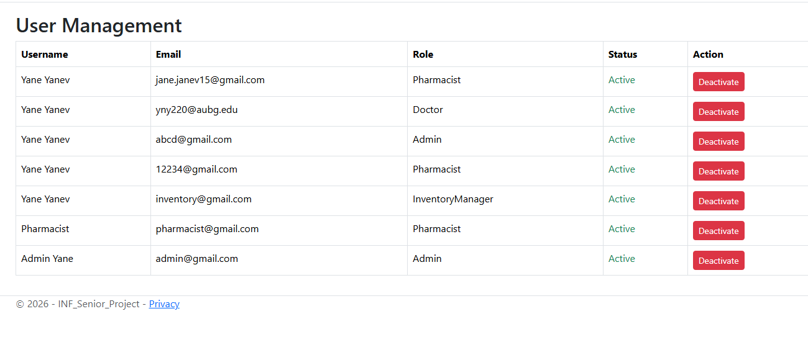
Figure 6 User Management Screen
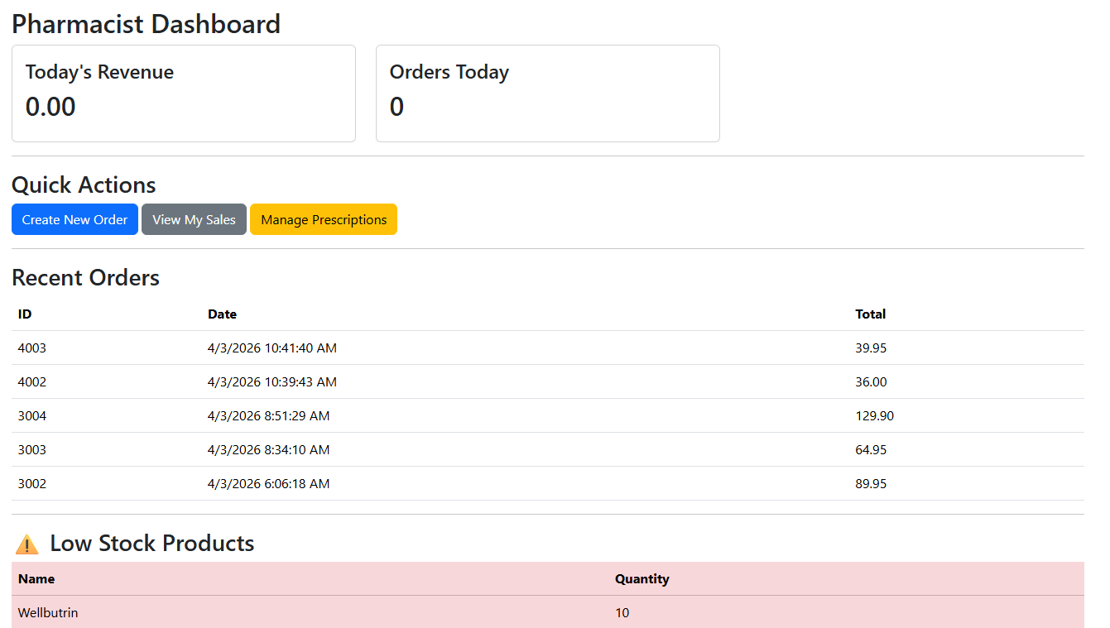
Figure 7 Pharmacist Dashboard
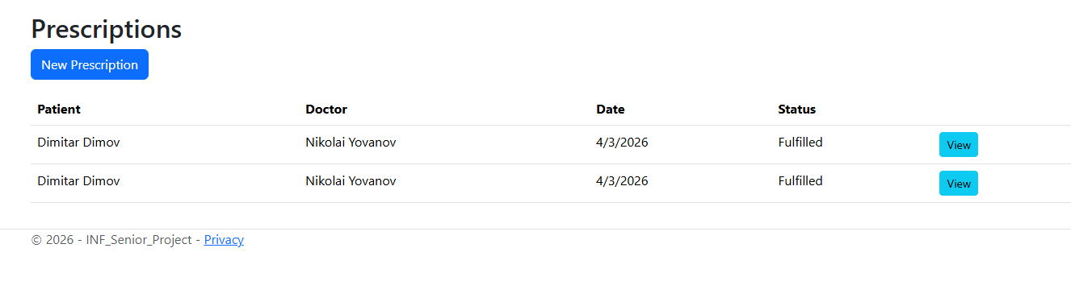
Figure 8 Perscriptions Screen
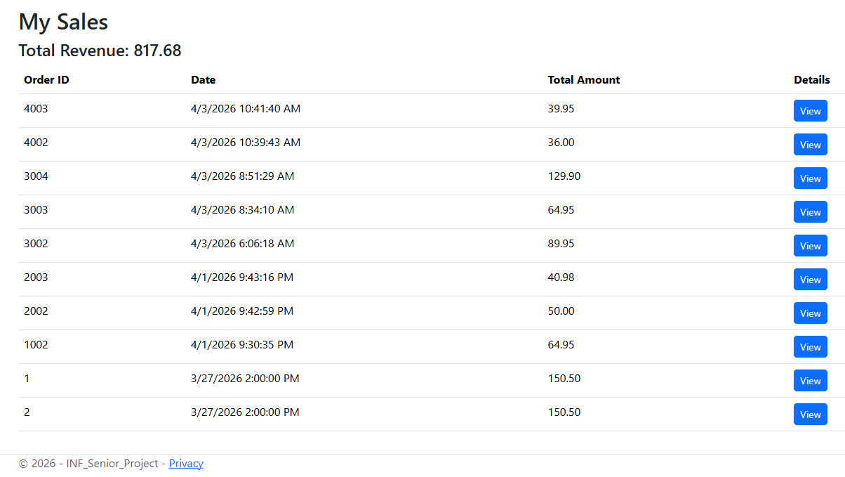
Figure 9 Sales Screen
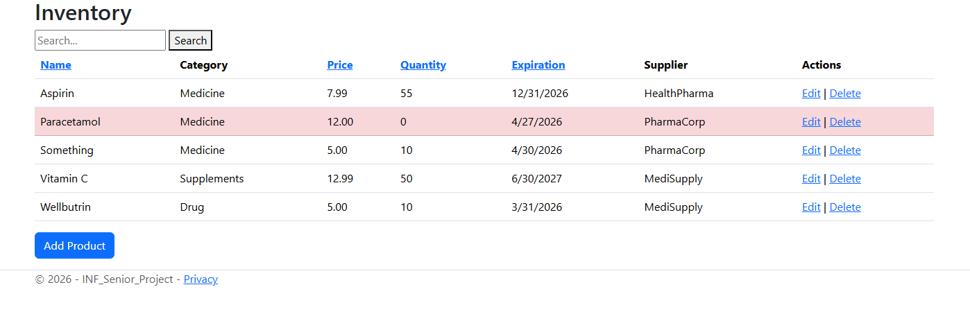
Figure 10 Inventory Screen
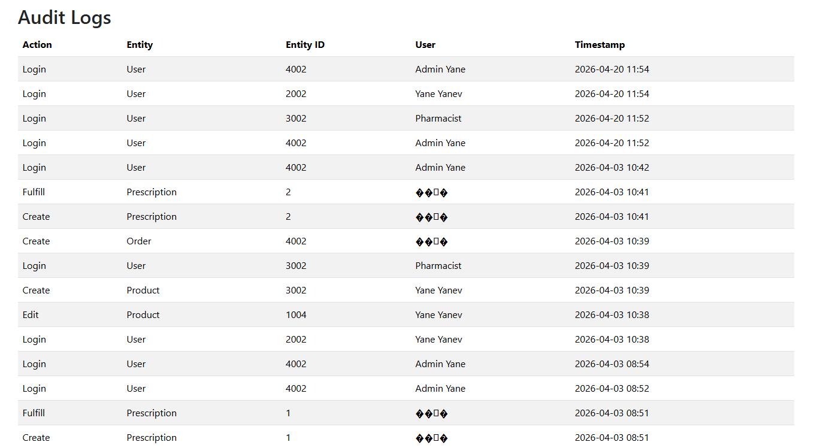
Figure 11 Audit Logs Screen
The completed application includes multiple working pages such as login, registration, dashboards, inventory lists, order creation forms, prescription screens, and audit log pages. These screenshots should be inserted into the final printed report to visually demonstrate the completed system.
In the final submission, these example images should be replaced with real screenshots taken from the completed Pharmacy Management Service while running locally.

6.4 Future Development
If development continued, several additional improvements could be introduced. Barcode scanner support would speed up product sales and stock entry. Automatic reordering could notify suppliers when stock becomes low. Expiration alerts could warn staff before medicines expire.
The project could also be extended into a mobile application for pharmacists or managers. Cloud deployment would allow access from multiple devices and locations. Two-factor authentication would improve security, and advanced reporting dashboards would provide deeper business insights.
From a testing perspective, future work could include automated browser tests, performance testing under heavy usage, and expanded coverage beyond the current automated unit tests.

6.5 Knowledge and Skills Gained
This project provided significant practical learning experience. It strengthened knowledge of ASP.NET Core MVC architecture, controller design, Razor views, routing, validation, and model binding. It also improved database knowledge through Entity Framework Core, migrations, relationships, and CRUD operations.
Security concepts such as password hashing, session management, and role-based authorization were applied in practice rather than only studied theoretically.
The project also improved understanding of software engineering processes, including requirements analysis, ER modeling, system planning, debugging, and testing. Learning how to create automated xUnit tests was especially valuable because it introduced professional development practices used in industry.

Personal Development
Beyond technical growth, the project improved problem-solving ability and persistence. Large systems rarely work perfectly on the first attempt, so debugging and redesign were important parts of development. The project also improved confidence in building complete software solutions independently.
Time management and planning skills were strengthened because the project required dividing a large objective into smaller tasks such as authentication, inventory, prescriptions, and testing. Completing these tasks step by step was essential to finishing the project successfully.

Conclusion
The Pharmacy Management Service was successfully completed as a practical and realistic software system for pharmacy operations. It provides secure authentication, role-based dashboards, inventory management, order processing, prescription workflows, administrative control, and audit logging in one integrated platform.
Compared with the original expectations, the final product became more advanced and more complete than initially planned. It moved beyond a simple database project and developed into a multi-user management application with meaningful business logic and automated testing.
Although future enhancements are possible, the current version already demonstrates strong technical ability and a clear understanding of modern software development practices. The project was successful both academically and practically, and it provides a strong foundation for future expansion into a larger commercial pharmacy solution.

7. References

Bootstrap. (n.d.). Get Bootstrap Documentation. From getbootstrap.com: https://getbootstrap.com/docs/
Microsoft. (n.d.). Entity Framework Core. From learn.microsoft.com: https://learn.microsoft.com/en-us/ef/core/
Microsoft. (n.d.). Hierarchical Data SQL Server. From learn.microsoft.com: https://learn.microsoft.com/en-us/sql/relational-databases/hierarchical-data-sql-server.
Microsoft. (n.d.). Microsoft ASP.NET Core. From Microsoft.com: https://learn.microsoft.com/en-us/aspnet/core/
Microsoft. (n.d.). Microsoft Relation Database Design. From microsoft.com: https://learn.microsoft.com/enus/sql/relational-databases/database-design
Microsoft. (n.d.). Razor Pages and Views in ASP.NET Core. From learn.microsoft.com: https://learn.microsoft.com/en-us/aspnet/core/mvc/views/overview.%20Accessed%2017%20Apr.%202025
Microsoft. (n.d.). SQL Server Docummentation. From learn.microsoft.com: https://learn.microsoft.com/en-us/sql/sql-server/
Microsoft. (n.d.). Unit Testing with dotnet test. From learn.microsoft.com: https://learn.microsoft.com/en-us/dotnet/core/testing/unit-testing-with-dotnet-test
Oracle. (n.d.). MySQL 8.0 Reference Manual. From My SQL: https://dev.mysql.com/doc/
Gamma, E., Helm, R., Johnson, R., & Vlissides, J. (1994). Design Patterns: Elements of Reusable Object-Oriented Software. Addison-Wesley.

